Objectives:

* Using the while and for loops
* **There are 5 challenge exercises, each worth 20%**

Please submit this document for grading when completed… Please work in groups.

This lab class exercise is based on Chapter 4 Loops.

**Project #1** (using the for loop and getting the square root)

**Project #2** (using the for loop, and getting the sum of numbers)

**Challenge exercise #1:** continuing with project #2, get the average of the 5 numbers also.

**#1 Print screen the output with the code below here.**

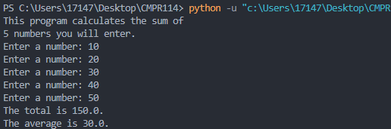

Code

MAX = 5

total = 0.0

print("This program calculates the sum of ")

print(f"{MAX} numbers you will enter.")

for counter in range(MAX):

    number = int(input("Enter a number: "))

    total = total + number

avgval = total / MAX

print(f"The total is {total}.")

print(f"The average is {avgval}.")

**Project #3:** Retail validation program using the while loop.

Validating the entry of the wholesale cost, see blue arrow bottom.

**Project #4:** Property Taxes, using the while loop.

**Challenge Exercise #2: complete the following program below:**



**#2 Print screen the output with the code below here.**

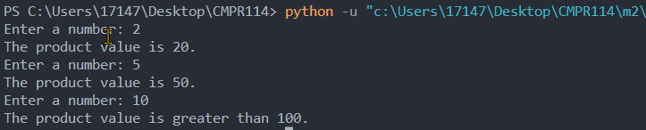

Code:

xval = 10

product = 0

while product < 100:

user_input = int(input("Enter a number: "))

product = user_input * xval

if product < 100:

print(f"The product value is {product}.")

else:

print("The product value is greater than 100.")

break

**Challenge Exercise #3: complete the following program below:**

**#3 Print screen the output with the code below here.**

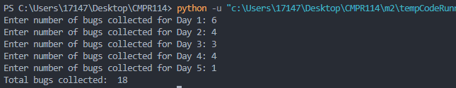

Code:

MAX= 5

totalcnt = 0

for days in range(MAX):

    bugcnt = int(input(f"Enter number of bugs collected for Day {days+1}: "))

    totalcnt = totalcnt + bugcnt

print(f"Total bugs collected:  {totalcnt}")

**Challenge Exercise #4: complete the following program below:**

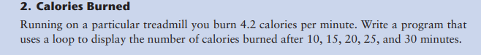

**#4 Print screen the output with the code below here.**

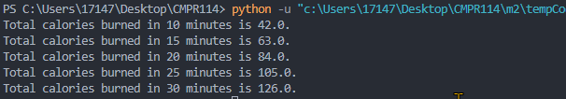

Code:

calsmin = 4.2

for display in (10,15,20,25,30):

    totalcal = display * calsmin

    print(f"Total calories burned in {display} minutes is {totalcal}.")

**Challenge Exercise #5: complete the following program below:**

**#5 Print screen the output with the code below here.**

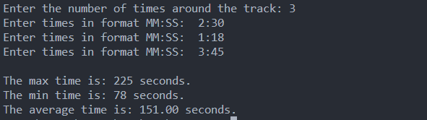

Code:

from datetime import time

maxval = 0

minval = 0

totaltime = 0

def convert_to_sec(min, sec):

total = 0

if min > 0:

total = (min * 60)

if sec > 0:

total = total + sec

return total

counter = int(input("Enter the number of times around the track: "))

for loop in range(counter):

timestr = input("Enter times in format MM:SS: ").split()

for time in timestr:

min, sec = [int(i) for i in time.split(":")]

timeval = convert_to_sec(min, sec)

totaltime = totaltime + timeval

if timeval < minval or minval == 0:

minval = timeval

if timeval > maxval:

maxval = timeval

avgval = totaltime / counter

print(f"\nThe max time is: {maxval} seconds.")

print(f"The min time is: {minval} seconds.")

print(f"The average time is: " + format(avgval, ",.2f") + " seconds.")

**Submit this document to the module 2 class exercise.**